Grangetown Nursery School


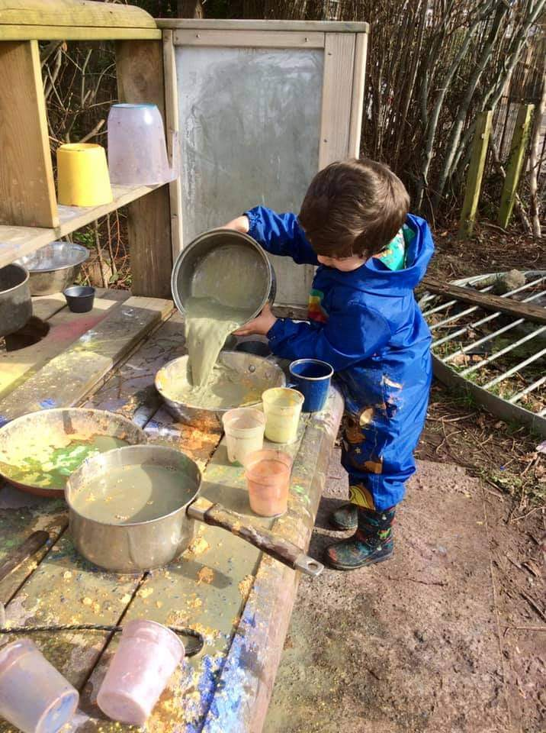

School Improvement Plan 2022-2023



SIP Priorities

School Improvement Priorities 2022 - 2023
Priority 1 | To ensure well-being of ALL stakeholders remains a priority and is the core of our professional relationships
Priority 2 | To ensure that teaching and learning approaches solidify our curriculum design and provide opportunities to organically assess learners, meeting individual needs
Priority 3 | To embed and strengthen our community links by implementing our community engagement project

Key
EIG | MEAG | RRRS (ALPS) | EYPDG | Charitable Grant | Professional Learning Grant | School Fund | Links to Evidence | SIP 23/24

SIP 1: To ensure well-being of ALL stakeholders remains a priority and is the core of our professional relationships

Success Criteria

- All staff ensure learner’s needs are met consistently and effectively.
- For ALL children to have high quality educational provision throughout the whole school day
- Introduce a new approach to staff appraisals that give more experienced teachers and teaching assistants the opportunity to lead appraisals. Areas of development are addressed through CPD and ongoing constructive dialogue with trusted team members opportunities
- Regular supervision meetings to have a place to ‘check in’ and talk through ideas, challenges or issues that staff can share in a confidential and supportive way.
- Big Bocs Bwyd food shop running to give local community opportunity to volunteer services to run shop and buy affordable essentials.
- Big Bocs Bwyd Community Café built and open for parents and local community to support by volunteering and have access to enjoy relaxing and socialising together.
- Families and local community access to outdoor spaces for growing healthy and nutritious food.
- Staff to set up a monthly lunch club for colleagues to enjoy healthy, nutritious food and being together.
- Opportunities for staff to team build through activities and experiences that promote health and wellbeing.
- All staff to support transitions efficiently and sensitively

Actions | Personnel |  | Timescale | Resource/  Costs / Source of Finance | Monitoring and Evaluating Impact
Check in with learners and observations over first 4 full weeks to establish how pupils are feeling and what steps are needed for progression (Baselines) | All teaching staff |  | September – October 22 |  | The initial home visit allows staff to ascertain a real insight in the child and their family. This provides information that helps the transition from home to school. Thus, securing a robust transition plan and meeting the needs of learners.  The initial assessments enable staff to assess the learners’ stage of development upon entry and then they construct appropriate individualised next steps for learners and the appropriate support in order to achieve these. Initial assessments identify children who’s needs are beyond universal provision. This will impact planning and provision within the setting and provide interventions and adaptations ensuring accessible learning for all  (Building Blocks)
All pupils to have daily opportunity to ‘check-in’, talk about their feelings and the impact on their emotional well-being (at a stage appropriate level) E.g. Circle time, group time | All staff |  | September 22 – July 23 |  | Supporting learner’s wellbeing and knowing the whole child is at the core of everything we do. We place a huge emphasis on the learners being able to recognize and communicate their feelings. Through Thrive and daily interactions staff gauge each individual’s emotional state and how to support this. Having flexible routines allows changes as and when needed and supports learners showing them their heard and respected. Observations informed changes to the Rhythm of the Day in order to allow time and space for these check ins. (THRIVE, Well-Being screening, Observations)
Inform parents and governors of attendance targets and monitor absence closely | HT |  | Termly |  | Governors agenda always has attendance on so termly updates are provided. Using our Miss School Miss Out policy, we remind parents of the importance of good attendance. We also contact after two consecutive absences if these have not been authorised to check in on the families. This supports the school’s links with families and the genuine relationships built.  (Miss School Miss Out Policy, Attendance figures)
Opportunities for parents to be a part of children’s learning embedded throughout the year | All staff |  | September 22 – July 23 | EYPDG for immersion day resources | Termly Festivals where families are celebrated and join the school in fun days, e.g Winter Festival. The school also provides immersion days such as Forest School, Gardening where Parents are welcome to join their children and engage in learning with them at specific points of the year. The school also ascertains the interests/skills of parents and will ask if they want to share these within the school. Volunteering Programme for our Grangetown Kitchen Garden (Pictures and posters of Festivals, Parental Questionnaires, Example of Home Visit form)
Work with multi agencies to identify vulnerable pupils and families at risk. | ALNCo ad HT |  | Termly |  | Working in collaboration with EYIT, Educational Psychologist and SALT enables a solid team around the child and ensures the learner’s needs are fully met.  (ALNCo file, IDPs etc)
Ensure specialist agencies can support targeted vulnerable learners at given opportunities – E.g. EP, Neuro and Play therapist support etc | ALNCo ad HT |  | Termly |  | We have genuine, respectful relationships with these agencies and this allows for seamless, collaborative work  (ALNCo file, IDPs etc)
Vulnerable + ALN pupils continue to have access to external support. | ALNCo ad HT |  | September 22 – July 23 |  | Our ALN learners receive relevant and appropriate external support. The impact of these are outlined in external reports, IDPs and PCP meetings.  (ALNCo file, IDPs etc)
Re-establish and embed THRIVE and other intervention programmes to support emotional well-being of targeted pupils | All teaching staff |  | September 22 – July 23 | PLG for supply cover | KH has been fully trained in THRIVE and has identified learners. YO is also undertaking ECLIPSE and intervention groups for those learners that need additional support.  (THRIVE and Intervention files, Observations)
Opportunities for both staff and pupils to talk- THRIVE, Mindfulness etc. | SLT |  | September 22 – July 23 |  | Well-Being Wednesday is starting to ensure we make time for coming together and having social time without the constraints of work. Staff meetings address issues and concerns as and when they arise. Staff know that the HT and SLT have an open-door policy and therefore can come to them when needed. Agencies of support or signposted and any information on county services are circulated with staff.  (Well-being file, minutes of staff meetings, staff appraisals, staff questionnaires)
Meetings with staff to check on wellbeing- signpost if necessary to appropriate agency. | SLT |  | Half Termly
Re-establish behaviour and learning expectations so that children feel safe, calm, and able to learn effectively | All staff |  | September 22 – July 23 |  | Positive Behavior Policy outlines the strategies in place within the school to support learners. Observations informed changes to the environment and the expectations of learners are continually revisited. There is a consistent approach amongst staff. Impact of environment on learner’s behavior and distribution of staff has been observed and this will continually be monitored. (observations, pictures of changes within the setting and staff minutes, values, Frobel file)
ALNCo to attend relevant WG/CSC/LA CPD training exploring:  - What is good differentiation?  - What is constitutes good T&L for ALN?  - Evidence based interventions for learners with ALN | ALNCo and HT |  | As and when timetabled | PLG for supply cover | ALNCo has kept up to date with all relevant changes and procedures in place both locally and nationally.  (ALNCo file)

SIP 2: To ensure that teaching and learning approaches solidify our curriculum design and provide opportunities to organically assess learners, meeting individual needs

Success Criteria

- The school has effective provision in place for systematic and structured skills development across the school and in line with CFW
- Teaching, learning and provision makes direct impact in addressing the gaps in learning
- Pupils apply their literacy, numeracy and digital skills across the curriculum at a stage appropriate level
- Nearly all pupils demonstrate motivation to learn, positive attitudes and are keen and happy to learn
- Nearly all pupils make at least the expected progress in relation to their baseline
- Establish and develop clear assessment arrangements
- Nearly all staff to plan more desirable difficulties/problem solving learning experiences to challenge, extend thinking and encourage questioning
- Nearly all learners to connect and apply their knowledge and skills to pupil led enquiry focus and projects to create ideas and products

Actions | Personnel | Timescale | Resource/  Costs / Source of Finance | Monitoring and Evaluating Impact
Baseline assessments to be completed for learners | All teaching staff | September – October 22  January – March 23 |  | Baselines are completed upon entry, within 6 weeks of starting. These are then reviewed Spring and Summer Term.  MER Cycle ensures assessments feed planning and individual learners’ needs are met. This ensures provision consistently evolves with learners needs and is accessible to all. Therefore, providing the environment as the third educator.  (planning, assessment, changes to environment)
Re-establish Rhythm of the Day and Provision to meet the individual learning needs within our school community | SLT | September 22 |  | Adaptations to teaching and learning took place as a result of reflective practice. The school has made changes to how they plan and distribute themselves as staff and how the learning environment looks. These changes have increased the engagement of learners and the confidence & independence they have in accessing provision. We need to consistently reflect on our practice to ensure organic changes happen as and when the learners needs evolve. (planning, assessment, changes to environment)
Further improve, develop and refine a range of teaching and learning strategies across the school that promote a joy for learning, enable all pupils to make at least expected progress and promote best practice pedagogy within the limitations of the climate: e.g. Collaborative learning, team teaching, outdoor opportunities etc. | All teaching staff | September 22 – July 23 | PLG for supply cover | Collaborative work with TLP, ECCC & TNS in progress.  Joint INSET on Assessment in January 23 allowed for professional dialogue and reflection on current practice.  Collaborative approaches to teaching and learning all align with ALNET and C4W.  Cluster Planning and AOLE outlines as well as out Cluster RSE Policy and Curriculum.  Frobel training and how this has impacted our teaching and learning, constantly reflecting on provision and practice.  Observations informed to changes to the outdoor learning environment. Changes being completed Summer 23 – to be reviewed  (planning, assessment, Cluster Team files, TLP work)
Ensure pupils have a greater voice in how they learn – independently and interdependently | All staff | September 22 – July 23 |  | Pupil voice is strong and is reflected within the environment, provision and practice.  (Displays, floorbooks, lines of enquiry, planning)
Further develop identifying next steps for learning so that there are clear learning journey’s for learners to make at least expected progress or higher | All teaching staff | September 22 – July 23 |  | Reflective practice and peer to peer working allows us to review our teaching and learning consistently. This ensures we evolve with the learners. (assessment, learning journeys, Observations and floorbooks)
Develop a clear understanding of assessment arrangements and processes; working in collaboration with the 2 Nursery schools ad TLP | SLT | September 22 – July 23 | PLG for supply cover | Working in collaboration with TLP and Nursery HTs we are developing assessment arrangements that are bespoke to our settings. These are keeping in line with national guidance.  (assessment policy and supporting documents, building blocks, planning)
Challenge and extend pupils creative thinking. | All staff | September 22 – July 23 |  | Through pupil voice, lines of enquiry and fascinations of the learners. Desirable difficulties and challenges placed within the environment and careful considerations given these opportunities within our planning processes. (medium term planning, observations, floorbooks, learning journeys)
Ensure work is set to each child’s ability- differentiation of tasks. | All staff | September 22 – July 23 |  | Well established and thought out IDPs for those ALN learners. Reflective practice and professional dialogue daily that informs planning.  (ALNCo file, Medium term planning, Staff meeting minutes)
Clear baseline assessment to plan and monitor pupil intervention and progress. Close the gap. | All teaching staff | September 22 – July 23 |  | Baselines carried out each term to monitor progression. These are aligned with C4W progression steps and in-house assessment tools. These feed into planning and provide effective teaching and learning.  (assessment policy and supporting documents, building blocks, planning)
Continue to work in collaboration with the cluster on concepts of the curriculum and AOLEs | SLT | September 22 – July 23 | PLG for supply cover | This work is ongoing and is providing excellent networks for the cluster. Working in partnership has enabled a firmer understanding of each AOLE within the age phases and given a platform for joined up working, where each school provides an area of expertise to share and develop.  (Teams channel with all relevant documents)
Meaningful, authentic learning that embraces the locality, community and all it has to offer | All staff | September 22 – July 23 | EYPDG | The school has acquired a Minibus which allows even more opportunity to for learning through trips beyond our locality.  Continue links with our community committee  (medium term planning)

SIP 3 To embed and strengthen our community links by implementing our community engagement project

Success Criteria

- Establish working relationships with local community groups and charities.
- Host community events in partnership with local community groups and charities that bring members of the community together through growing food, sharing food and cooking food.
- Research opportunities of funding to develop and strengthen our community engagement
- Develop our community allotment and growing project
- Establish a link with an outside childcare provider to offer wrap around in The Reach and provide the community with more quality provision
- Many children to become food literate and understand farm to table
- All staff to promote sustainability and care for the world around them
- Most learners to be aware of their locality and what community means
Actions | Personnel | Timescale | Resource/  Costs / Source of Finance | Monitoring and Evaluating Impact
To continue to be a valuable member of the network of Big Bocs Bwyd schools and to promote priorities | JM and NB | September 22 – July 23 |  | Attend termly network meeting and ensure national priorities align.  (minutes from meetings & Teams channel)
To promote the REACH as a community facility and secure some regular bookings during the week, e.g Toddler Groups, Language classes for parents, Coffee Mornings etc | SLT | September 22 – July 23 |  | Community Committee set up and meet termly. Strong partnerships have been made.  (Strategic Plan and Committee minutes and Agendas)
To ensure our termly planning includes community and allows opportunity for the children to invite parents in to increase collaboration | All teaching staff | September 22 – July 23 |  | Through community committee meetings we look for opportunities to work in collaboration. We also stay a breath of what is happening in the locality, e.g Grangetown Carnival and ensure the school gets involved. Staff take an invested interest in the families and respect them as the learner’s first educators and the school looks to involve the parents as much as possible.  (planning, floorbooks, Home Visit information)
Working in collaboration with community groups in particular United2Change and embrace our shared visions and values and promote this within the community | JM and NB | September 22 – July 23 |  | Our community has grown and the opportunities and experiences on offer for the families is going from strength to strength.  (Strategic Plan and Committee minutes and Agendas)
Establish our community café and give ownership of the day to day running systems to our volunteers | JM and NB | September 22 – April 23 |  | This has made some progress but needs further development. Strategic plan is in place and community groups are taking responsibility for specific areas of the café.  (Strategic Plan and Committee minutes and Agendas)
Opportunities for children to explore and learn within their locality to be carried out through provision weekly | All staff | September 22 – July 23 |  | Extending children’s learning beyond the school has had many benefits. The children are familiar with their locality and can discuss local shops, landmarks etc. They have respect for where they live and have developed a sense of belonging. Opportunities for wider learning is always considered in planning meetings and responses to pupil’s fascinations.  (medium term planning, observations & field notes)

Considerations for SIP 23/24
Priority 1

Curriculum & Assessment – Frobel (Cardiff MET Research project), RSE (cluster & N), Diversity and Equity (Stella training), Assessment (TLP – core strands e.g m&n, l & dcf), Rights Respecting School, Curriculum Review with Nursery HTs

Priority 2

Continue to strengthen our Community Focused School - Community Committee, Grangetown Kitchen Garden, Community Cafe

Priority 3

Leadership – Distributed leadership & development of SLT due to changes, Governor Self- Evaluation, clear lines of responsibility across SLT

