

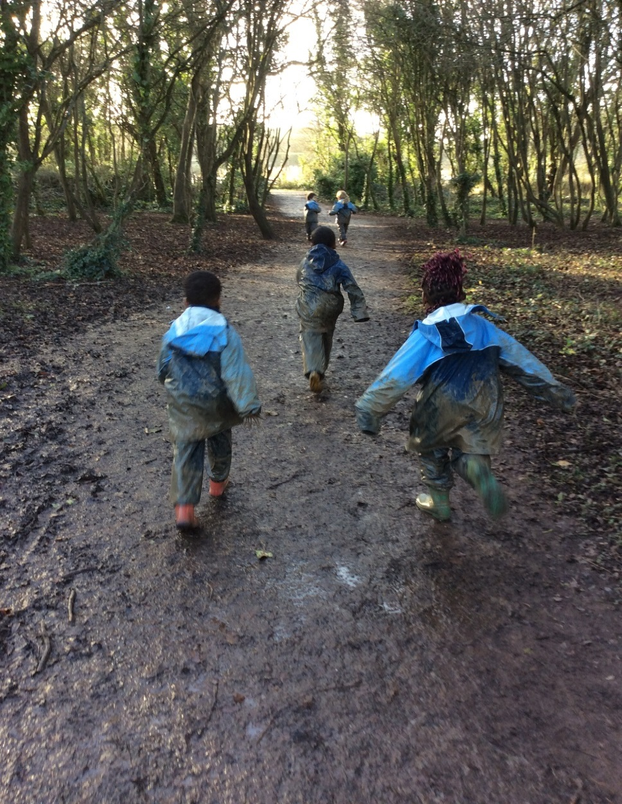

Healthcare Needs Policy
Grangetown Nursery School
Avondale Road,
Grangetown,
Cardiff,
CF11 7DT
02920 345026
grangetownns@cardiff.gov.uk

Key Principles
The aim at Grangetown Nursery School is to ensure that children with medical conditions receive appropriate care and support. All children have an entitlement to a full time curriculum or as much as their medical condition allows. This policy has been developed in line with the Welsh Government document– “Supporting learners with Healthcare Needs” and City of Cardiff Council “Meeting the Health Care Needs of Children and Young People in Cardiff”
Legal Requirements
Section 175 of the Education Act 2002 places a duty on local authorities and governing bodies to safeguard and promote the welfare of children in setting and this includes supporting children with healthcare needs.
Key roles and responsibilities
The Local Authority is responsible for:
- Ensuring that children with healthcare needs receive a suitable education
- Providing support, advice and guidance, including how to meet the training needs of staff
- Making arrangements to promote co-operation between various bodies and ensuring appropriate agreements are in place for data sharing

The Governing Body of Grangetown Nursery School is responsible for:
- Ensuring arrangements are in place to support children with medical conditions.
- Ensuring the policy is developed collaboratively across services and is implemented effectively.
- Ensuring that all children with medical conditions are able to play a full and active role in all aspects, participate in visits / trips/ sporting activities, remain healthy and achieve their academic potential.
- Ensuring that relevant training is delivered to a sufficient number of staff who will have responsibility to support children with medical conditions and that they are signed off as competent to do so. Staff are to have access to information, resources and materials.
- Ensuring written records are kept of all medicines administered to children.
- Ensuring the policy sets out procedures in place for emergency situations.
- Ensuring the level of insurance in place reflects the level of risk.
- Handling complaints regarding this policy as outlined in the School’s Complaints Policy

The Headteacher is responsible for:
- Ensuring the policy is developed effectively with partner agencies and that staff aware of this policy.
- The day-to-day implementation and management of the policy
- Liaising with healthcare professionals regarding the training required for staff.
- Identifying the staff that need to be aware of a child’s medical condition.
- Developing Individual Healthcare Plans (IHPs).
- Ensuring a sufficient number of trained members of staff are available to implement the policy and deliver IHPs in normal, contingency and emergency situations.
- If necessary, facilitating the recruitment of staff for the purpose of delivering the promises made in this policy. Ensuring more than one staff member is identified, to cover holidays / absences and emergencies.
- Ensuring the correct level of insurance is in place for teachers who support children in line with this policy.
- Continuous two-way liaison with Health Care professionals in the case of any child who has or develops an identified medical condition.
- Ensuring confidentiality and data protection

Staff members are responsible for:
- Taking appropriate steps to support children with medical conditions and familiarising themselves with procedures which detail how to respond when they become aware that a pupil with a medical condition needs help.
- Knowing where medication is stored
- Taking account of the needs of children with medical conditions in school
- Undertaking training to achieve the necessary competency for supporting children with medical conditions, with particular specialist training if they have agreed to undertake a medication responsibility.

Parents and carers are responsible for:
- Keeping the School informed about any new medical condition or changes to their child/children’s health.
- Participating in the development and regular reviews of their child’s IHP.
- Completing a parental consent form to administer medicine or treatment before bringing medication into school
- Providing the school with the medication their child requires and keeping it up to date including collecting leftover medicine.
- Carrying out actions assigned to them in the IHP with particular emphasis on, they or a nominated adult, being contactable at all times.

The Learner is responsible for:
- Informing parent/carer or staff members if feeling unwell

Health Professionals (NHS Wales) are responsible for:
- Offering advice on the development of IHPs
- Assisting in the identification of the training required
- Supporting staff through advice and liaison with other healthcare, social care and third sector professionals

Creating an accessible environment

Grangetown Nursery School is inclusive and accessible to learners with health care needs. This includes the following:
- The physical access to the setting – See Accessibility Plan
- Reasonable adjustments – auxiliary aids or services are provided in response to the individual healthcare needs of the learner
- Social interactions – the involvement of children with healthcare needs is fully considered and any barriers to social interactions removed
- Food management – consideration is given to the dietary needs of children with healthcare needs and alternatives made available
- Risk assessments – seeking adjustments to existing provision in order to promote inclusion. Staff are aware of the risk assessment systems in place

Day trips and off site activities
- Arrangements will be made to ensure children with medical conditions can participate in trips and other off site activities and will not prevent them from doing so unless a clinician states it is not possible.
- Risk assessments are undertaken for including children with medical conditions. Consultation with parents, healthcare professionals etc. on trips and visits will be separate to the normal day to day IHP requirements.

Sharing Information
Staff have access to the relevant information, particularly if there is a possibility of an emergency situation arising. Respect to confidentiality is adhered to and the information is kept up to date. Parents are asked to sign a consent form to permit information to be shared with relevant professional bodies as necessary
Procedures and record keeping for the management of learners’ healthcare needs
A medical conditions list or register is kept, updated and reviewed regularly. Each member of staff has an overview of the list for the children in their care, within easy access. Supply staff and support staff have access on a need to know basis. Data sharing principles are adhered to at all times
Storage, access and the administration of medication

- Where possible, unless advised it would be detrimental to health, medicines should be prescribed in frequencies that allow the child to take them outside of Nursery hours
- If this is not possible, prior to staff members administering any medication, the parents/carers of the child must complete and sign a parental consent to administration of medicine form.
- No child will be given any prescription or non-prescription medicines without written parental consent except in exceptional circumstances.
- Medicines MUST be in date, labelled, and provided in the original container (except in the case of insulin which may come in a pen or pump) with dosage instructions. Medicines which do not meet these criteria will not be administered.
- Medications will be stored in a safe place out of children’s reach
- Any medications left over at the end of the course will be returned to the child’s parents.
- Written records will be kept of any medication administered to children.
- Children will never be prevented from accessing their medication.
- Grangetown Nursery School cannot be held responsible for side effects that occur when medication is taken correctly.
- Staff will not force a pupil, if the pupil refuses to comply with their health procedure, and the resulting actions will be clearly written into the IHP which will include informing parents

Emergency Procedures
- Medical emergencies will be dealt with under the school’s emergency procedures which will be communicated to all relevant staff so they are aware of signs and symptoms.
- Children will be informed in general terms of what to do in an emergency such as telling an adult
- If a child needs to be taken to hospital, a member of staff will remain with the child until their parents arrive.

Training of staff
- All staff will be made aware of the ‘Meeting the Healthcare Needs of Children’ Policy as part of their induction.
- The clinical lead for each training area/session will be named on each IHP.
- No staff member may administer prescription medicines or undertake any healthcare procedures without undergoing training specific to the condition and signed off as competent.
- The school will keep a record of medical conditions supported, training undertaken and a list of teachers qualified to undertake responsibilities under this policy.

Insurance arrangements
City of Cardiff County employees, who undertake responsibilities within this policy and have completed the necessary training, are protected by Public Liability insurance.

Complaints procedure
- All complaints should be raised with the school in the first instance.
- The details of how to make a formal complaint can be found in the school’s Complaints Policy.

Individual Healthcare Plans (IHPs)
- Where necessary an Individual Healthcare Plan (IHP) will be developed in collaboration with parents/carers, Headteacher, Additional Needs Coordinator and medical professionals.
- IHPs will be easily accessible to all relevant staff, including supply/agency staff, whilst preserving confidentiality. A photo and instructions will be displayed. In the case of conditions with potential life-threatening implications the information will be available clearly and accessible to everyone.
- IHPs will be reviewed at least annually or when a child’s medical circumstances change, whichever is sooner.
- Where a pupil has an Education, Health and Care plan or Individual Development Plan, the IHP will be linked to it or become part of it.

Review of Policy: September 2024

